

**Salesforce.com Reports Functional Design**

Version 1.0

February 5, 2014

**Copyright © 2014 Unisys Corporation**

**All rights reserved**

**Unisys Corporation Confidential**

**Revision History**

|  |  |  |  |
| --- | --- | --- | --- |
| Version | Date | Author | Summary of Changes |
| 1.0 | 2/5/2014 | Sreelatha SK | Initial draft |
|  |  |  |  |
|  |  |  |  |
|  |  |  |  |
|  |  |  |  |
|  |  |  |  |
|  |  |  |  |

**Reviewers**

| Name | Position |
| --- | --- |
|  |  |
| Graham Quinn  Daniel Ramos  Kim Adams | City – SME Reviewers |
| Sheryl Johnson  Elizabeth Martens | City – Other Reviewers |
|  |  |

Table of Contents

Table of Contents 3

1 Overview 4

2 Reporting and Analytics Requirements 4

2.1 Reporting and Query Capability 4

2.2 Advanced Analytics and Dashboard Capability 5

3 Pilot Implementation 5

4 Citywide Implementation 6

5 Assumptions 6

6 Supporting Business Rules 6

7 Appendix 7

# Overview

This document defines the requirement gathering for generation of Reports for Service Requests and Information Requests configured. The dashboards and reports listed below will be at different level namely, executive-level, management-level and agent-level.

# Reporting and Analytics Requirements

This section defines the Reporting and Query Capability, Advanced Analytics and Dashboard Capability required by City.

## Reporting and Query Capability

1. The solution provides ability to generate reports based on a set of key performance indicators as designated by City of Philadelphia
2. The solution provides a set of standard reports that will provide statistical reporting, including but not limited to:

* Open service requests
* Closed service requests
* Past due service requests
* Service requests related to an address, location or intersection
* Service requests that have been escalated
* Service requests that are classified as high priority/urgent

1. The solution provides ability for all reports to be date sensitive, including the ability to print for prior year’s data, fiscal year or calendar year
2. The solution provides ability for reports to be run against both current and archived data
3. The solution provides backlog, service activity, and closure rate statistics for all work order activities
4. The solution provides ability to report on quality measures such as number of ticket reassignments and quality of ticket entry and updates
5. The solution provides ability to generate variance analysis reports comparing the actual time to complete to the estimate provided to the constituent
6. The solution provides ability to generate "hot-spot" reporting for geographic areas in pre-defined zones (e.g., zip code, census tract, etc.) or user-defined areas
7. The solution provides number of inquiries per division/department
8. The solution provides reporting on customer satisfaction
9. The solution provides ability to print copies of records, standardized forms, emails, and letters
10. The solution allows reports to be viewable on the screen, in hard-copy format, or available over the web (if security has been allowed to do this for this report)
11. The solution allows report results to be viewed in graphical format
12. The solution allows report results to be viewed on a map
13. The solution allows user friendly ad hoc query capabilities that do not require a user to understand backend database table structure
14. The solution provides ability to create calculated fields
15. The solution allows multiple users to develop and run queries simultaneously
16. The solution allows query selection criteria to be named and saved for future use
17. The solution allows newly defined reports to be added to the product's menus
18. The solution allows for scheduling of pre-defined reports that can be waiting for the staff or pushed to them via email on demand, monthly, weekly, etc.
19. The solution provides wizards to help guide the report writing process
20. The solution provides that the report writer contain an author log, users, and date of most recent update
21. The solution provides ability to utilize pivot tables in the reports
22. The solution provides the ability to flag reports or certain elements of the report as confidential and set permissions for access to reports
23. The solution provides ability to filter reports by department and for department to secure access to departmental reports
24. The solution provides report writer capabilities for the development of custom reports (e.g. Crystal Reports)
25. The solution provides the ability to export report data into other applications and formats (e.g. PowerPoint, Excel, Adobe, comma delimited, SQL, etc.)
26. The solution provides that report writer allow direct export of a report or attachment to email
27. The solution provides ability to print labels, including mailing labels for constituent related mailings
28. The solution provides ability to generate letters with appropriate formatting for mailing or sending via email
29. The solution provides ability to record when and which types of form letters have been sent
30. The solution provides ability to store copies of correspondence sent in an electronic/digital format
31. requirements needed to create the Standard Article Type, which provides the format and structure that controls how these articles are displayed within the Salesforce application (channel = Internal App, Partner, Custom, Public Knowledge Base).

## Advanced Analytics and Dashboard Capability

1. The solution provides dashboard capabilities that will display reporting information based on user's defined role within the CRM system
2. The solution provides ability to customize dashboard information based on user's desired level of information
3. The solution provides real-time analytics to capture key reporting and metrics
4. The solution provides the ability to assign and/or link management summary reports for comparison over time and benchmarking against other municipalities
5. The solution provides ability to generate reports based on constituent surveys
6. The solution provides ability to conduct trending analysis
7. The solution provides ability to search and report on data associated with service requests such as agent, constituent contact information, address, FAQ article, special event, weather issue and/or request type

# Pilot Implementation

This section defines the requirements for the Dashboard and Report configuration required for Pilot implementation. The reports should include the criteria mentioned below. Refer Appendix for sample reports.

1. 311Philly_Call Center Management : Performance Data Report

* Top requests by *Category*, by *Department*, by Inquiry type & number of *Information Request*.
* *Information Request* by *Department* and topic based (Group by *Service Request* type)
* Requests by Channel wise *(Email & Walk-in)*

1. 311Philly_Supervisory level & 311Philly_Agents level

* Number of tickets by Agent by type (*Service Request* Type & *Information Request*)
* Individual versus team (*Supervisor, Agent*)
* # of items (Cases) Escalated

1. 311Philly_Contact Center Manager

* By Supervisor Team

1. 311Philly_Dashboard/Service Request Users (biggest users)

* Past SLA/ ticket status/ Escalated

1. 311Philly_Executive level

* Ticket status by *Department*

# Citywide Implementation

*<Will be done after Pilot Implementation>*

# Assumptions

The following table defines the assumptions of conditions that must be true for a successful implementation:

| **Assumption #** | **Assumption Description** | **Comments** |
| --- | --- | --- |
| ASSUMP1 | The report is dependent on the data present in the Salesforce. |  |
| ASSUMP2 | City will confirm on the Access level for Reports configured for Pilot Implementation |  |

# Supporting Business Rules

The following defines the additional business rules needed to support Dashboard and Report generation within Salesforce:

| **Rule #** | **Business Rule Description** | **Comments** |
| --- | --- | --- |
| BRULE001 | **Access level** includedExecutive-level, Management-level and Agent-level.  Roles to be configured include <Manager??>, <Supervisor>, 311 Contact Center Agent |  |
| BRULE002 | **Executive-level** Report should only be visible to Roles with   * Manager?? |  |
| BRULE003 | **Management-level** Report should only be visible to Roles with   * Supervisor?? * Manager |  |
| BRULE004 | **Agent-level** Report should only be visible to Roles with   * Agent * Supervisor * Manager |  |

# Appendix

Snapshot of the sample reports are shared below. The test data created are limited and may not be sufficient to generate the report as seen in real-time scenario.

1. Service Request versus Department

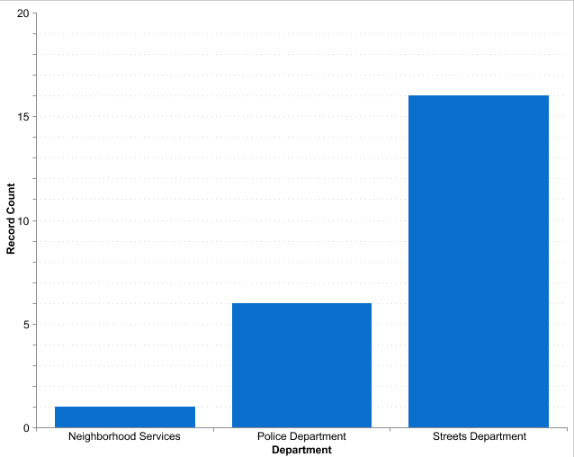

1. Request versus Street (Address)

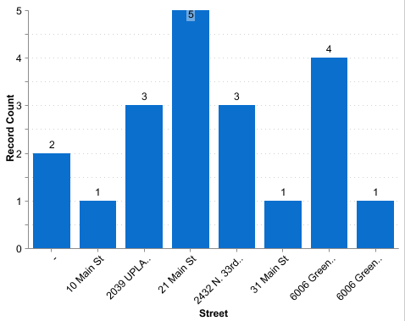

1. Information Request versus Department

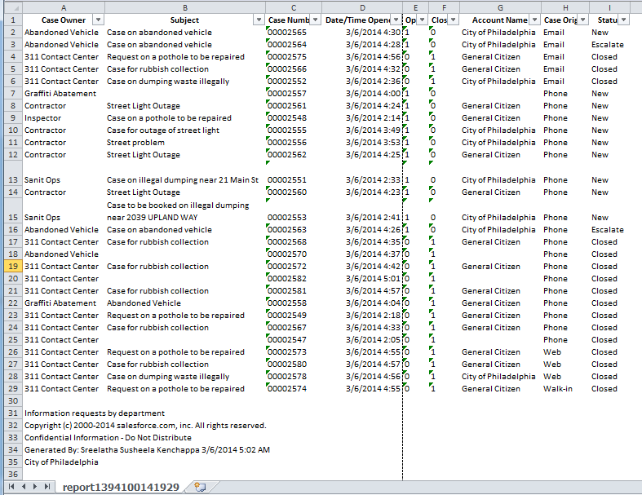

1. Case versus Origin

